1. Introduction to Selenium
2. Software to Install

**Introduction to Selenium**

Selenium is the SUITE(Not a Single tool) of Software tools to automate WEB(Only) applications across different Operating System (Windows, Linux, Apple OS)and Browsers(FF ,IE,Opera, Chrome, Safari)

The same code can used for all browsers execution. We have to write Separate code to launch each browser

2004 Selenium was created by Jason Huggins

2006 selenium IDE was created by Shinya Kasatani

2206 Selenium Web driver was launched at Google

2008 Selenium Web Driver and Web driver RC

Components of Selenium

1. Selenium IDE
2. Selenium RC
3. Webdriver
4. Grid

**Adavantages**

1. Open source,Freeware, and portable tool
2. Supports many OS,browsers and Programming lang
3. Parallael Test execution
4. Uses Very less CPU and RAM consumption for script execution
5. Can be integrated with Test NG testing frameworks for testing our applications and generating reports
6. Can be integrated with Jenkins for Continuous Integration

**Disadvantages:**

1. Only supports web based application and does not support windows based
2. No reliable support
3. No Maintenance of Object repository
4. Difficult to test image based applications
5. Difficult to set up env
6. For report generation activity like dependencies on TestNG or Jenkins

**Software to Install**

1. **Java**
2. **Eclipse**
3. **Selenium Java Client Driver**
4. **Browser Installation**

**Step 1 - Install Java on your computer**

Check if Java is installed in your machine Already and know what version/type, if installed?

If you are using windows / MAC /Linux then type in cmd prompt

**Java – version**

The below message will be shown

**Java version “1.8.0”**

**Java <TM> SE Runtime Environment**

If Java not installed. Please follow the below steps.

Download and install the **Java Software Development Kit (JDK)**[here](http://www.oracle.com/technetwork/java/javase/downloads/index.html).

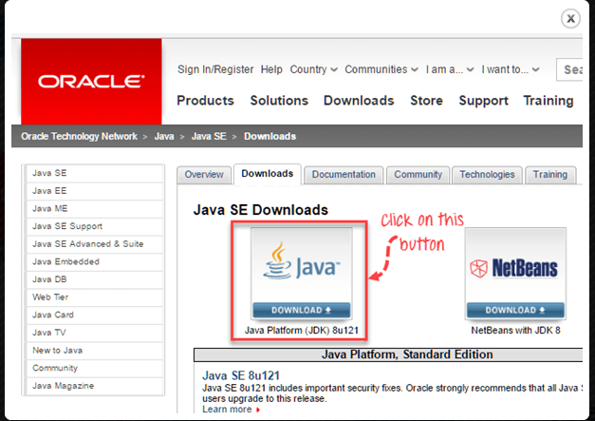

Next –

[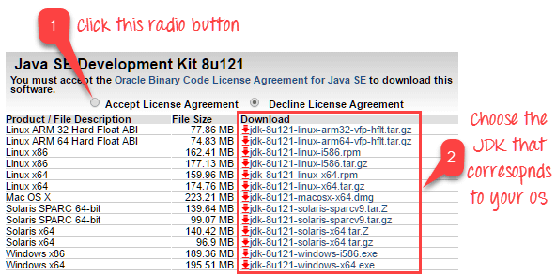](https://cdn.guru99.com/images/2-2017/022017_1205_Guidetoinst2.png)

This JDK version comes bundled with Java Runtime Environment (JRE), so you do not need to download and install the JRE separately.

Once installation is complete, open command prompt and type “java”. If you see the following screen you are good to move to the next step

[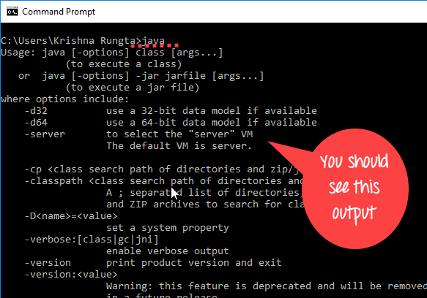](https://cdn.guru99.com/images/2-2017/022017_1205_Guidetoinst_24_7_1.png)

**Step 2 - Install Eclipse IDE**

Download "**Eclipse IDE for Java Developers**" [here](http://www.eclipse.org/downloads/). Be sure to choose correctly between Windows 32 Bit and 64 Bit versions.

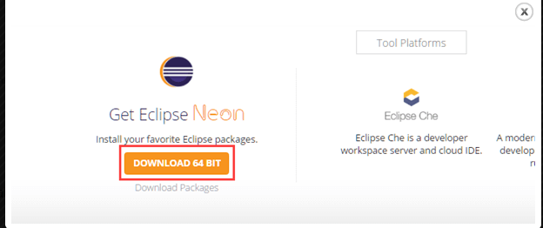

You should be able to download an exe file named "eclipse-inst-win64"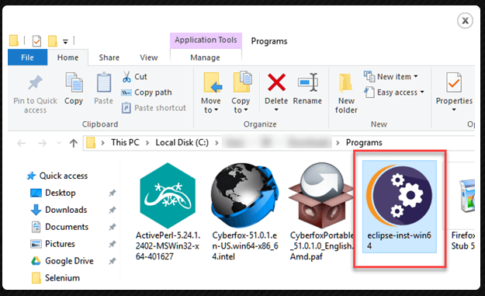

Double-click on file to Install the Eclipse. A new window will open. Click Eclipse IDE for Java Developers.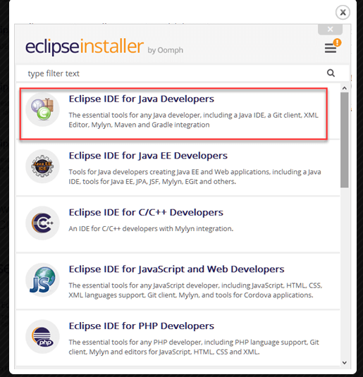

After that, a new window will open which click button marked 1 and change path to "C:\eclipse". Post that Click on Install button marked 2

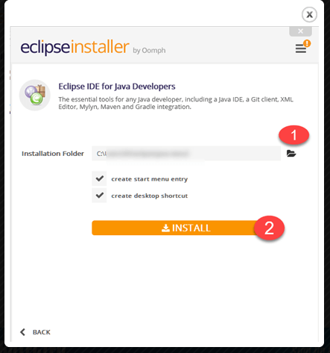

After successful completion of the installation procedure, a window will appear. On that window click on Launch

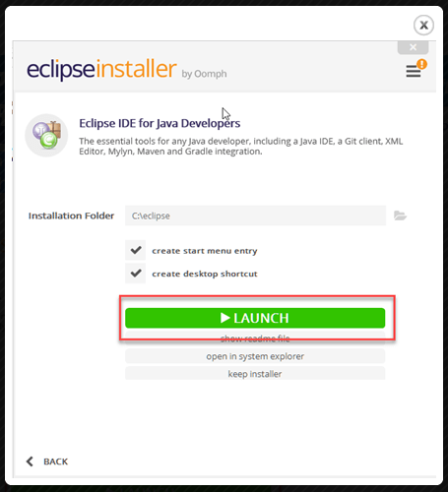

This will start eclipse neon IDE for you. Check

**Step 3 - Download the Selenium Java Client Driver**

You can download the **Selenium Java Client Driver** [here](http://seleniumhq.org/download/). You will find client drivers for other languages there, but only choose the one for Java.

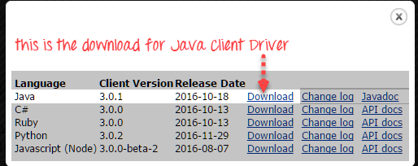

Step 4 – Browsers

Need to install Firefox(47+) and chrome browsers (atleast 53+) installed in laptop/desktop else selenium will not support your script.